Steps creating a heat model from the SVG sketch.

Run the ICCR2_pore.exe code

Type in the name of your svg file, make sure you have a corresponding control file

In our example, svg7.svg and svg7.cnt

You should get four output files

svg7_.geo ->This should be ready for GMSH, open in GMSH and then select 2D mesh.

svg7_data1D2D.geo ->You don’t need this, but its creating 1D element links to the boundary and through the system. This was used for analysing pore space, Ill send you a couple of files to try out.

The following two files are for the 1D links only. HOWEVER all the gli data for the void space is available from the gli file.

svg7_OGS_1D.gli

svg7_OGS_1D.msh

So, to set up the geometry of your model

1. Open the svg7_.geo file in GMSH, create a mesh, then save, you now have “svg7_.msh”

2. Open svg_7.msh with GINA, import, and save in a new modelling directory under e.g. “J1”

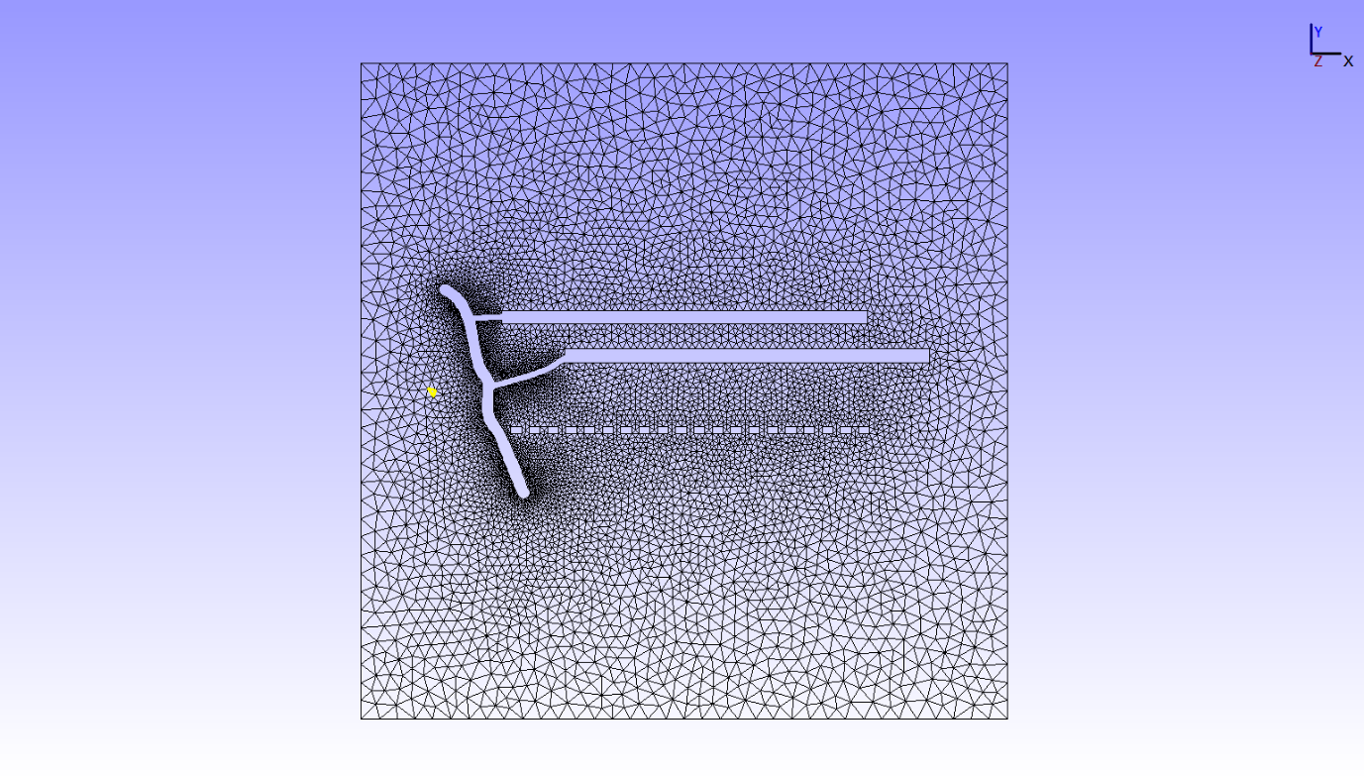

3. Using an editor copy the svg7_OGS_1D.gli file into your modelling directory, and rename it J1.gli, overwriting the existing gli file. Reload the J1 model, and you should see all your polylines

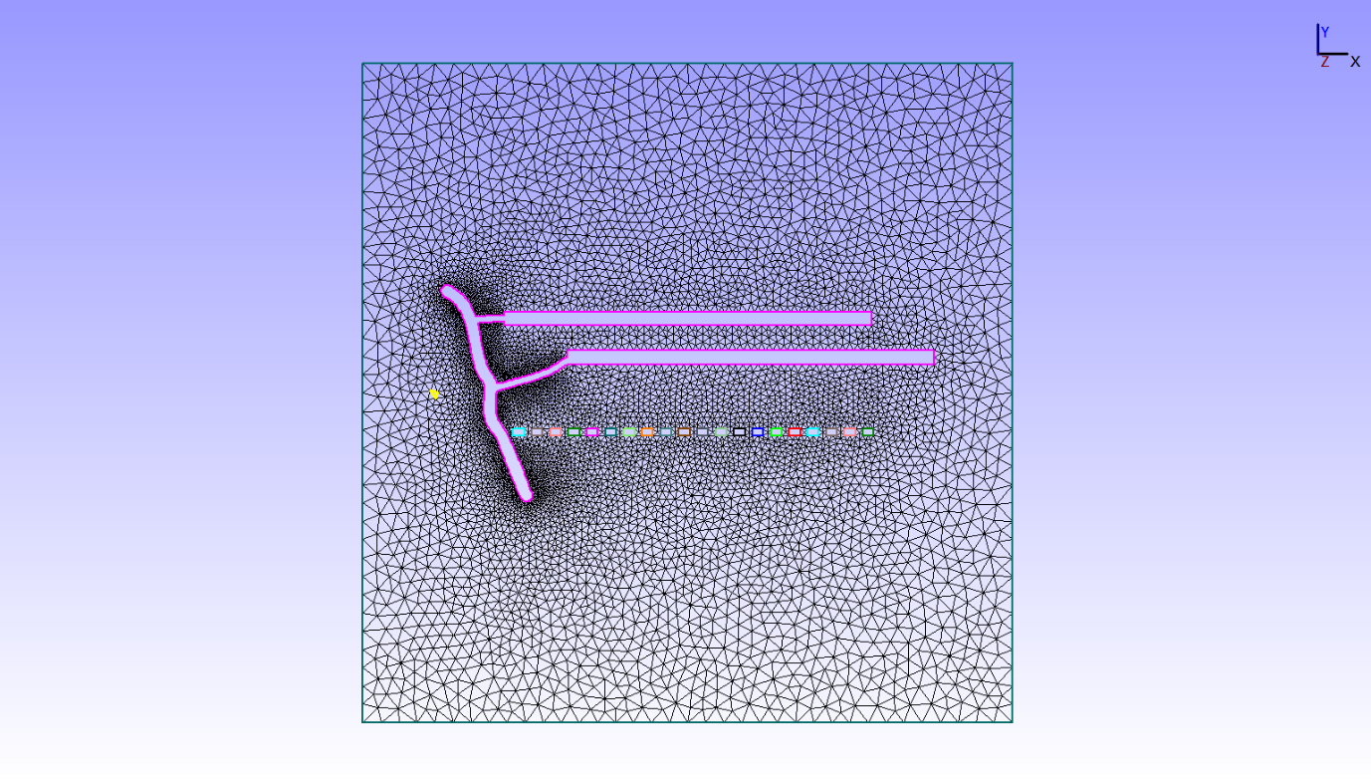

Now you should have all the polylines you will need to work with, including TOP, BOTTOM, LEFT, RIGHT for the whole area.